Name DAYAL ADITYA KISHOR

Class : FYMCA

Div: B

RollNo-18

ASSIGNMENT-10

DECLARE

A NUMBER :=:A;

B NUMBER :=:B;

C NUMBER :=:C;

D NUMBER;

PROCEDURE FINDMAX(X IN NUMBER, Y IN NUMBER , Z IN NUMBER, F OUT NUMBER)IS

BEGIN

IF X>Y AND X>Z THEN

F:=X;

ELSIF Y>X AND Y>Z THEN

F:=Y;

ELSE

F:= Z;

END IF;

END;

BEGIN

FINDMAX(A,B,C,D);

DBMS_OUTPUT.PUT_LINE('MAXIMUN OF ('||A||','||B||','||C||'): '||D);

END;

q.1

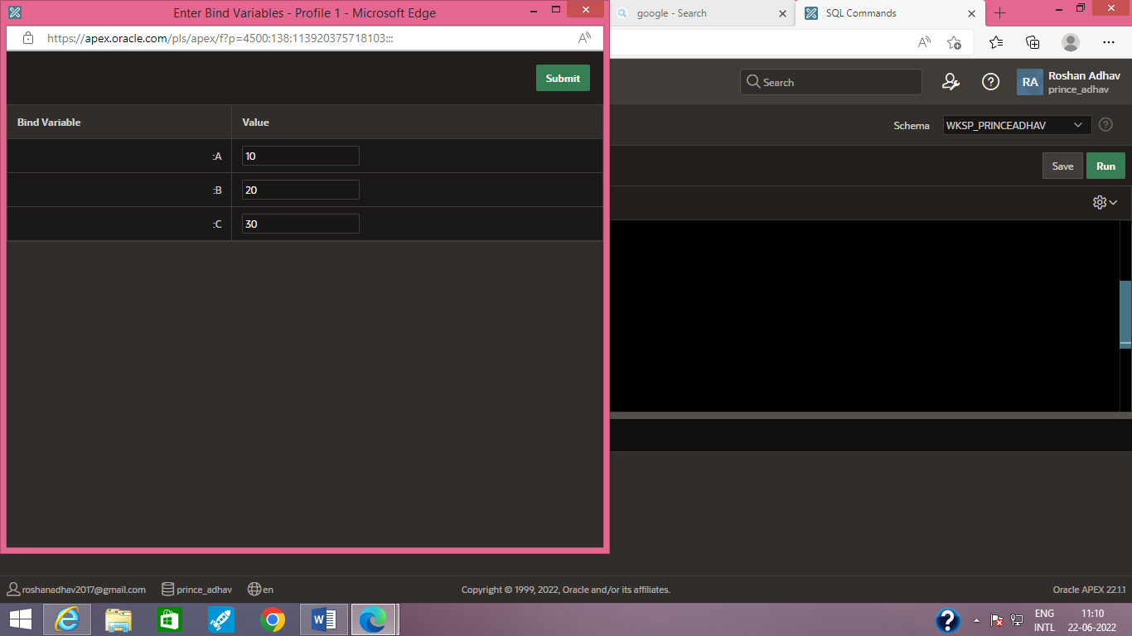

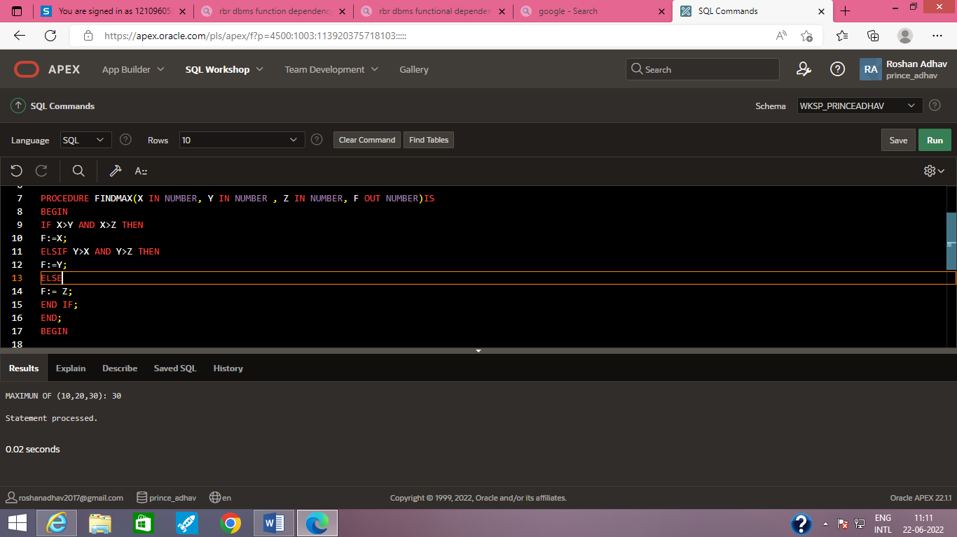

Q2.

DECLARE

BASIC_SALARY NUMBER:= :BASIC_SALARY;

GS NUMBER;

FUNCTION F1(BS IN NUMBER)

RETURN NUMBER

IS

GROSS_SALARY NUMBER;

BEGIN

GROSS_SALARY := BASIC_SALARY +(BASIC_SALARY *0.4)+(BASIC_SALARY*0.12);

RETURN GROSS_SALARY;

END;

BEGIN

GS:= F1 (BASIC_SALARY);

DBMS_OUTPUT.PUT_LINE('THE GROSS SALARY IS:'||GS);

END;